INF1103 Lab 7 Submission
1: Python files:
- can_be_shipped.py ✅
- product.py ✅
- physical_product.py ✅
- digital_product.py ✅
- inventory.py ✅
- inventory_manager.py ✅
2: Updated inventory.json file ✅
3: Updated UML Class Diagram ✅
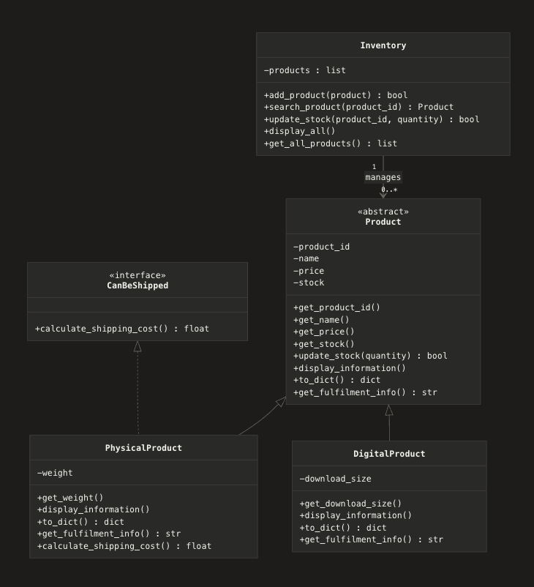
4: Git Log ✅

5: Docker container running successfully:
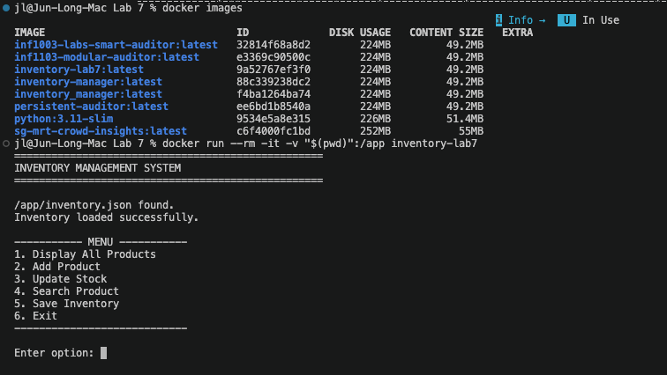
6: Screenshots of my program accepting input and producing the expected results:
(Added some product for testing previously)
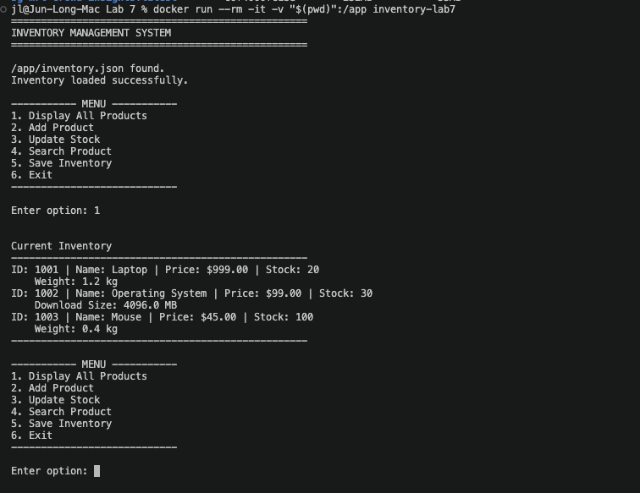

Adding new product:
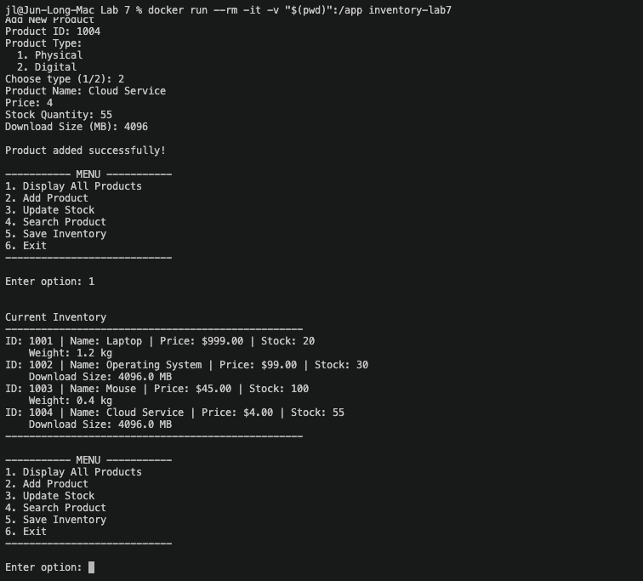
Searching for product:
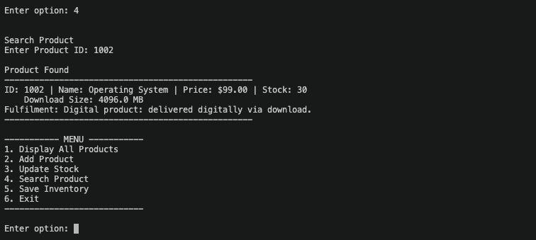

Updating Stock:
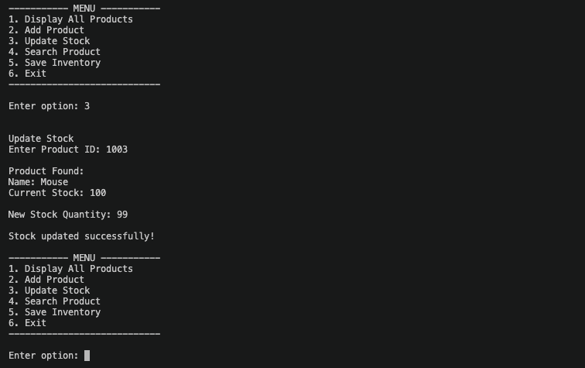
Saving the inventory and exiting the program:
